 ****

**PROTOTYPE DEVELOPMENT OF A PUSHER TYPE FIXED WING VTOL REMOTELY PILOTED AIRCRAFT SYSTEM**

**A PROJECT REPORT**

*SUBMITTED BY*

**VANDANA.M.S. (311018101042)**

**BALASUBRAMANIAN.S. (311018101301)**

**MOHAMED THOUFIQ.S.U. (311018101021)**

*in partial fulfillment for the award of the degree*

*of*

**BACHELOR OF ENGINEERING**

**IN**

**AERONAUTICAL ENGINEERING**

**KCG COLLEGE OF TECHNOLOGY**

**ANNA UNIVERSITY : CHENNAI 600 025**

**JUNE-2022**

**ANNA UNIVERSITY :: CHENNAI 600 025**

**BONAFIDE CERTIFICATE**

Certified that this project report **“****PROTOTYPE DEVELOPMENT OF A PUSHER TYPE FIXED WING VTOL REMOTELY PILOTED AIRCRAFT SYSTEM”** is the bonafide work of **“VANDANA.M.S, BALASUBRAMANIAN.S, MOHAMED THOUFIQ.S.U”** who carried out the project work under my supervision.

**SIGNATURE SIGNATURE**

Dr.K.VIJAYARAJA Mr.C.AASISH CHANDRA MOULI

**HEAD OF THE DEPARTMENT PROJECT SUPERVISOR**

Department of Aeronautical Engineering Department of Aeronautical Engineering

KCG College of Technology, Karapakkam, KCG College of Technology, Karapakkam,

Chennai 600097. Chennai 600097.

**INTERNAL EXAMINER EXTERNAL EXAMINER**

**ACKNOWLEDGEMENT**

We are thankful to **Dr. K. VIJAYARAJA**, Head of the Department of Aeronautical Engineering, KCG College of Technology, for the constant motivation and encouragement and the interest he has shown during our entire project.

We would like to express our whole-hearted gratefulness to our project guide, **Mr. C. AASISH CHANDRA MOULI**, Professor, Department of Aeronautical Engineering, for being the backbone of our project. We would like to thank his sincere and invaluable guidance, forthright suggestions and attitude and for being instrumental in keeping our spirits high and has helped in crowing our task with success project.

**ABSTRACT**

India’s backbone is Agriculture and our economy majorly depends on this industry. The use of modern tools and technologies can result in improved yield and it can have positive impacts on our country’s economy. This project of developing a hybrid fixed-wing Vertical Takeoff and landing (VTOL) can be used as a part of a smart farming technique. The recent developments in the country’s financial policies majorly focus on the use of drones in Agriculture “Kisan drones”. One such piece of equipment is our Hybrid VTOL. Our project deals with the design and fabrication of hybrid VTOL with state-of-the-art navigational instruments that will be a better fit for precision agriculture. Our VTOLs when equipped with imaging payloads can help farmers and analysts to gather field data. Crop yield analysis can be instantly carried out with the help of RGB color images and NDVI images received from our aerial vehicle. Hybrid VTOLs are capable of covering 400 acres in less than an hour and is possible to plan and control the entire mission with the use of a simple touch screen display. Further developments, with a ground control software solution we can enable access to stored maps, narrow down issues in specific fields, and detect subtle variations of crop health, the impact of climatic changes over time to make better decisions.

**KEYWORDS:**

Fixed wing, quadrotor, hybrid aircraft, Unmanned Aerial Vehicle (UAV), Vertical take-off and landing (VTOL).

**TABLE OF CONTENTS**

1.0.Prototype figure………………………………………………….. 10

1.1.Objective.................................................................................... 11

1.2.Methodology…………………………………………………. 11

1.3.UAV technology……………………………………………… 11

2.0.Literature survey

2.1.Flight test data analysis of hybrid vertical take-off and landing unmanned aerial vehicle……………………………………….……… 13

2.2.Autonomous payload delivery using hybrid VTOL UAV for community emergency response……………………………………………………14

2.3.Development of a quad-rotor fixed -wing hybrid unmanned aerial vehicle…………………………………………………………………. 15

3.0.Preliminary work

3.1.3D Views of VTOL…………………………………………… 16

3.2.Fabrication on testing model………………………………….. 17

3.3.Working images………………………………………….…… 18

3.4.Weight chart…………………………………………………... 19

4.0.Components

4.1.Material selection…………………………………………… 20

4.2.Fuselage…………………………………………………….. 21

4.3.Wing…………………………………………………………. 21

4.4.Motors ………………………………………………………. 22

4.5.Booms & mounts……………………………………………. 23

4.6.Battery…………………………………………………...….. 24

4.7.Flight controller…………………………………….………… 24

4.8.GPS & Receiver………………………………………….…… 27

4.9.Propellers……………….……………………………….…….. 31

4.10.Tail configuration…….……………………………………… 32

4.11.Landing gear……….………………………………………… 32

5.0.Testing process

5.1.Material weight estimation….………………………………..... 33

5.2.Display mode…………………………….…………………..… 33

5.3.Airfoil selection…………………………………………….….. 34

5.4.Flat bottom airfoil………………………………………….…….36

6.0.Modes of VTOL

6.1.Q-Stabilized………………………….…………...…………........37

6.2.Stabilized……………………………………………………........ 38

6.3.Manual……………………………………...…………..…….….. 38

7.0.Work analysis

7.1.Flow chart…………………..………………………………….…. 39

7.2.Working procedure……………………………………...…………40

7.3.Equipments…………….…………..………………...……….........40

8.Result and Conclusion…………..……………………………………. 41

9.Future works…………..………………………………………………. 42

10.References…………………………………….……………………… 43

**LIST OF FIGURES**

**SI NO FIGURE NO NAME PAGE NO**

**1** 1.0.1 CAD design of VTOL 10

**2** 1.3.1 General physical structure of an UAV 12

**3** 2.1.1 Analysis of hybrid VTOL 13

**4** 2.2.1 Payload hybrid VTOL 14

**5** 2.3.1 Quad-rotor fixed wing hybrid UAV 15

**6** 3.1.1 Front view of VTOL 16

**7**3.1.2 Side view ofVTOL 16

**8** 3.2 Fabrication on testing model 17

**9** 3.2.2 Weight estimation chart 18

**10** 3.3.1 Working images 18

**11** 3.4.2 VTOL weight estimation chart 19

**12** 4.1.1 XPS material 20

**13** 4.2.1 CAD Design of fuselage 21

**14** 4.3 Wing 21

**15** 4.4.1 XT2216-1150KV motor 22

**16** 4.4.2 1100KV motor 22

**17** 4.5.1 Booms 23

**18** 4.5.2 Motor mount 23

**19** 4.5.3 Motors fixed on booms 23

**20** 4.6.1 11.1V 2200mAH LIPO Battery 24

**21** 4.7.1 Orange cube controller 24

**22** 4.7.2 Top-side (GPS, TELEM etc) 26

**23** 4.7.3 Debug ports 26

**24** 4.7.4 USB/SD card ports 26

**25** 4.8.1 Global Positioning System 27

**26**  4.8.2 Receiver (PPM) 29

**27** 4.9.1 11 inch propellers 31

**28** 4.10 Tail configuration 32

**29** 4.11 Landing gear 32

**30**  5.1.1 Material weight chart 33

**31** 5.2.1 GPS mode 33

**32** 5.2.2 Satellite image 33

**33** 5.3.1 GOE526 airfoil 34

**34** 5.3.2 Airfoil chord image 34

**35** 5.3.3 Graph of Cl vs Cd35

**36** 5.3.4 Graph oh Cl/Cd vs Alpha 35

**37** 5.3.5 Graph of Cl vs Alpha 35

**38** 5.3.6 Graph of Cd vs Alpha 35

**39** 6.0.1 Flight test 37

**40** 7.2.1 Connection diagram 40

**41**  9.0.1 Hybrid 42

**42** 9.0.2 Glass fibre 42

**LIST OF TABLES**

**S.NO TABLE NO NAME PAGE NO**

**1** 3.2.1 Weight estimationtable18

**2** 3.4.1 VTOL weight estimation table19

**3** 4.10.1 Comparison of tail design 32

**4** 5.1.1 Material weight table 33

**5** 7.3.1 Table of elements 40

**CHAPTER 1**

**1.0. PROTOTYPE DEVELOPMENT OF A PUSHER TYPE FIXED WING VTOL REMOTELY PILOTED AIRCRAFT SYSTEM**

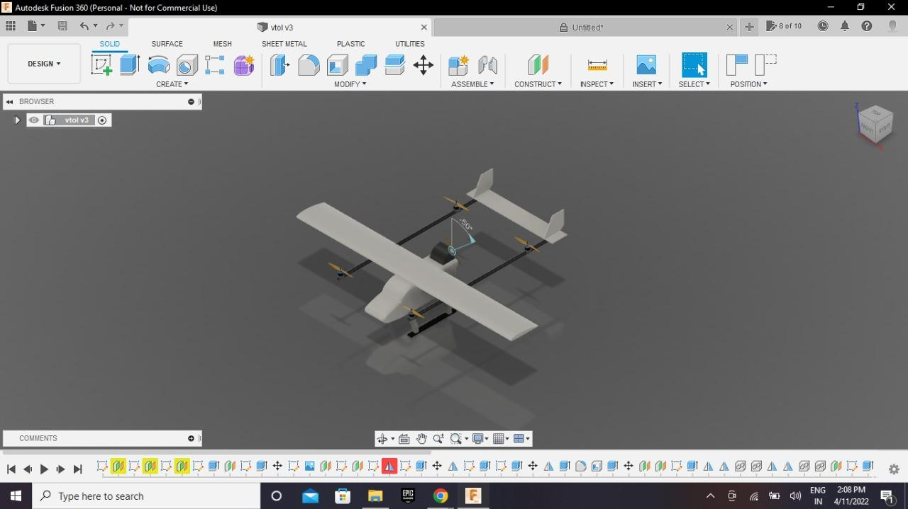

**Figure 1.0.1: CAD design of VTOL**

**1.1. OBJECTIVE:**

To develop a prototype of pusher type fixed wing VTOL (**V**ertical **T**ake **O**ff and **L**anding) and demonstrate the feature of switching between VTOL mode and fixed wing mode.

**1.2. METHODOLOGY:**

                           A pusher type fixed wing model is chosen as the base frame of the prototype. VTOL configuration booms are designed and installed to the base frame. The two configurations are propelled by electric and flying maneuvers are done using a flight control system and controlled remotely with a radio frequency transmitter and receiver. Switching of modes are executed manually from the switch assigned on the radio transmitter and controls are programmed to the flight controller for actuating the controls based on the flying mode.

**1.3. UAV TECHNOLOGY:**

   An unmanned aerial vehicle (UAV), commonly known as a drone, is an aircraft without any human pilot, crew, or passengers on board. UAVs are a component of a UAS, which includes adding a ground-based controller and a system of communications with the UAV.

The flight of UAVs may operate under remote control by a human operator, as remotely-piloted aircraft (RPA), or with various degrees of autonomy, such as assistance, up to fully autonomous aircraft that have no provision for  human intervention.

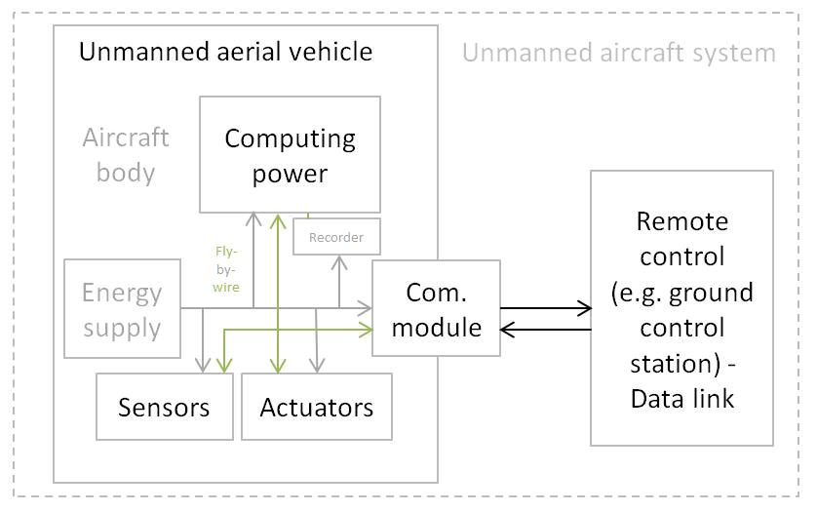

**Figure 1.3.1: General physical structure of an UAV**

UAV’s were originally developed through the twentieth century for military missions too dull, dirty or dangerous for humans, and by the twenty-first, they had become essential assets to most militaries. As control technologies improved and costs fell, their use expanded to many non-military applications. These include forest fire monitoring, policing and surveillance, infrastructure inspections, science, smuggling. An unmanned aerial vehicle (UAV) is defined as a "powered, aerial vehicle that does not carry a human operator, uses to provide vehicle lift, can fly autonomously or be piloted remotely, can be expendable or recoverable, and can carry a lethal or nonlethal payload". UAV is a term that is commonly applied to military use cases. However with warheads are not considered UAVs because the vehicle itself is a munition. Also, the relation of UAVs is unclear.UAVs may or may not include remote-controlled model aircraft. Some jurisdictions base their definition on size or weight; however, the US FAA defines any uncrewed flying craft as a UAV regardless of size.

**CHAPTER 2**

**2.0. LITERATURE SURVEY**

**2.1. Flight test data analysis of hybrid vertical take-off and landing unmanned aerial vehicle:**

**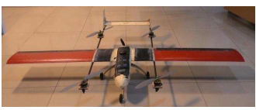**

**Figure 2.1.1: Analysis of hybrid VTOL**

                    This paper discussed the flight scenario that includes flight modes and parameters to be determined before flight. This leads to the development of the flight procedure as an important prerequisite for a successful flight. We start our study by performing flight tests in order to assess the feasibility of transition flight with the given UAV configuration. A working control system for each VTOL flight and cruise flight were prepared before performing transition flight. We take this approach as our design was built readily with its control equipment available for either fixed-wing flight or VTOL flight. For safety reason and maturity of the design, it is important to simulate the flight on the desk before flight at the field.

The automatic flight control system is designed using Hardware-In-the-Loop-Simulation (HILS) method by integrating flight controller hardware, X-Plane as visualizer, and Simulink as performance data receiver. The simulation is done for quadrotor and fixed-wing mode, but not for the transition stage.

**OUTCOME:**

This study by performing flight tests in order to assess the feasibility of transition flight with given UAV configuration.

**2.2. Autonomous payload delivery using hybrid VTOL UAV for community emergency response:**

**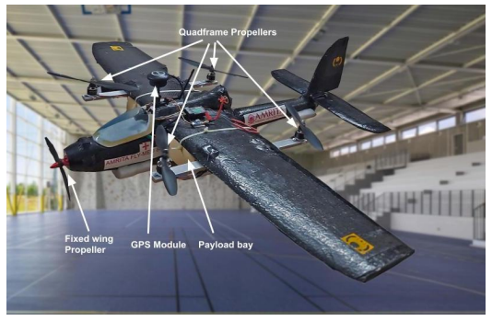**

**Figure 2.2.1: Payload hybrid VTOL**

                     This paper presents the design, development and flight testing of a hybrid vertical takeoff and landing unmanned aerial vehicles for targeted payload delivery to service local communities during emergencies. A hybrid quadrotor fixed-wing configuration, also known as a quad-plane has been described herein. The developed system is a separate lift and thrust (SLT) hybrid VTOL UAV.The system attempts to selectively incorporate the advantages of a fixed wing and a quad rotor. It can vertically take off and land at any given location and can perform a static payload delivery by hovering or landing at a given predefined location. The quad rotor part of the plane can operate in various VTOL modes. The forward flight is achieved by means of a bldc motor installed in tractor configuration at the nose of the aircraft. The quad rotor assists the fixed wing during the forward flight till it reaches its stall velocity, beyond which the quad motors are turned off and the quad plane flies in fixed wing forward cruise mode. At this instant the complete transition is achieved from VTOL mode to fixed wing mode. This hybrid mix enables the quad plane for long distance targeted payload delivery operations with a capacity to take off and land vertically from a specified location.

**OUTCOME:**

The system is designed to carry payload up to 600g for a flight duration of around 15 minutes.

**2.3.Development of a quad-rotor fixed -wing hybrid unmanned aerial vehicle:**

**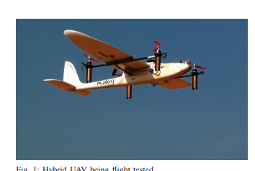**

**Figure 2.3.1:Quad-rotor fixed wing hybrid UAV**

This paper describes the development of a quadrotor fixed-wing hybrid unmanned aerial vehicle (UAV). By combining the flying qualities of quadrotor UAV and that of fixed-wing UAVs it is possible to achieve superior flying qualities. This way, the vertical take-off and landing capability of quadrotors and the long endurance of fixed wing UAVs have been put together, while eliminating the disadvantages of both of these UAV types. The proposed hybrid drone has shown exciting performance in taking off, cruising and landing fully autonomously.In this project, Sky Scout fixed-wing UAV was used as the fixed-wing platform onto which a quadrotor UAV frame was attached. Quadrotor thrusters were selected with enough lifting power. Pusher thruster was designed to give the UAV adequate forward thrust in fixed-wing mode flight mode. Two flight modes were tested and tuned independently, and then control transition from quadrotor to fixed-wing and implemented based on the forward airspeed. Finally, a complete survey grid mission was planned and implemented fully autonomously. Autonomous take off, control transition based on altitude, cruise, backward control transition, and vertical landing were all demonstrated successfully.

**OUTCOME:**

The fixed-wing UAV VTOL was very stable and reasonably quick take-off was achieved, however an altitude loss was observed in the forward flight transition.

**CHAPTER 3**

**3.0. PRELIMINARY WORK**

**3.1. 3D VIEWS OF VTOL:**

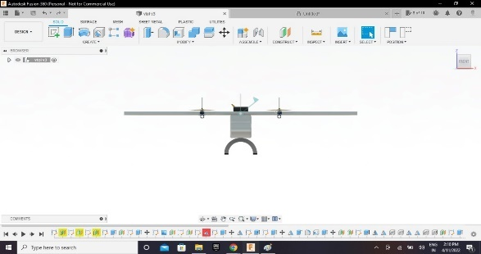             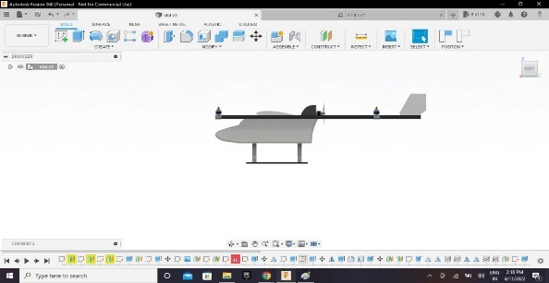

**3.1.1: Front view OF VTOL                      3.1.2: Side view OF VTOL**

For the design and construction of VTOL prototype, traces of the build plan were sketched. With the help of traces, construction of core of the body (or) fuselage, wing, h-tail, nose was accomplished with the depron sheets. The constructed parts were assembled to bring out a basic structure of desired drone. The servos, motors, esc’s, gps, battery was implanted. VTOL features was incorporated into explorer model by fitting motor mounts. For flying the model, programming is done on flight controller. Camera payload is mounted on the front face of the fuselage for the monitoring purpose. Weight estimation chart is prepared to obtain optimised weight estimation of our product. Lighter the aircraft, we obtain better manuverability. In addition to it, worked on material selection and short listed as mentioned in the below table.

**3.2. FABRICATION ON TESTING MODEL:**

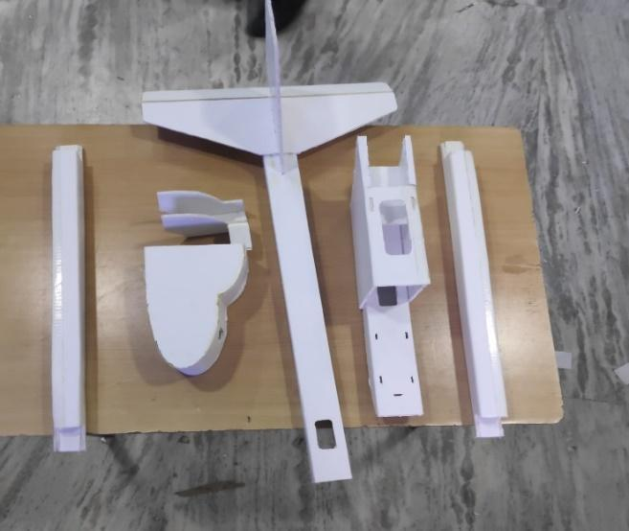   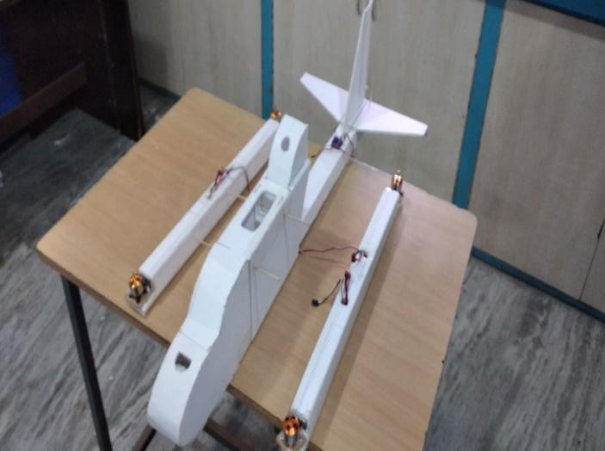

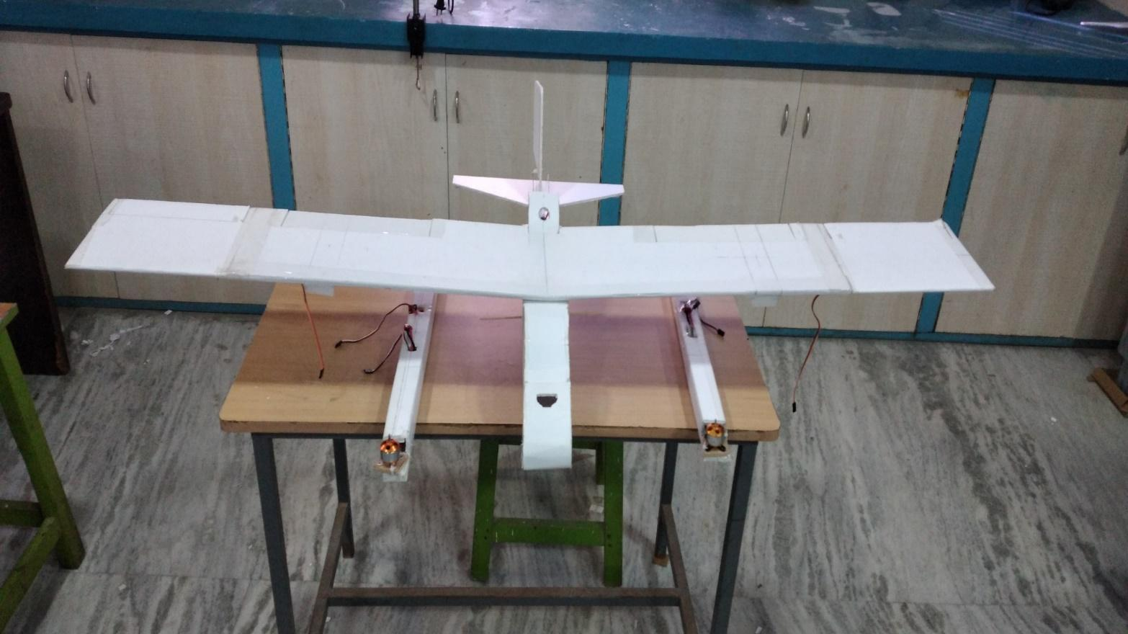

First step we have fabricated our 3d model using foam material.Its weight estimation table has been given below.

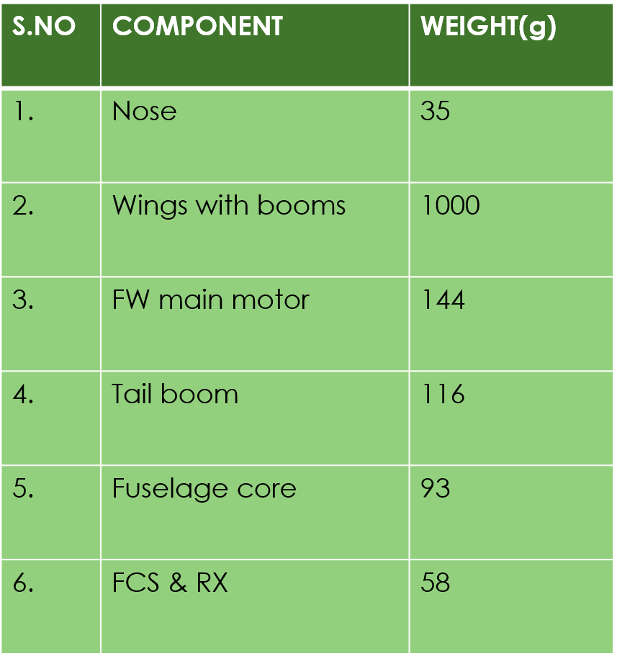          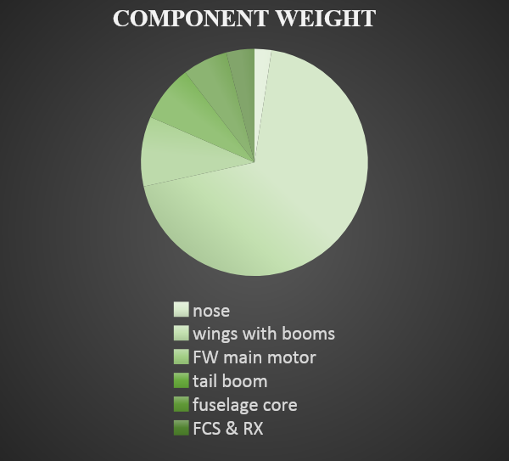**Figure 3.2.1: Weight estimation Figure 3.2.2: Weight estimation chart**

**table**

To reduce weight the model has been done with high density foam material shown below.The two foam booms also changed to composite pipes to fix motors and the tail has been designed in h-tail.

**3.3. WORKING IMAGES:**

**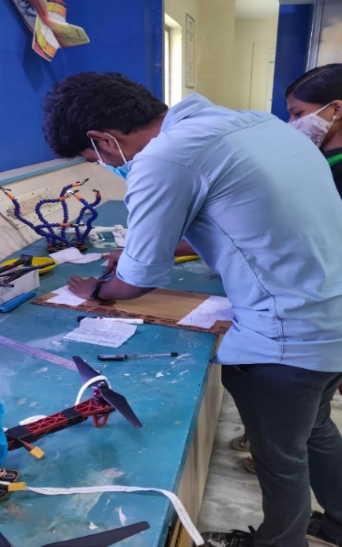**    **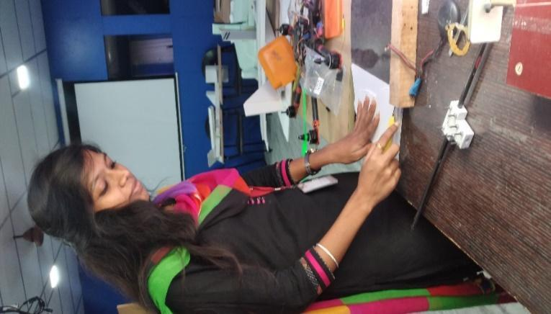**   **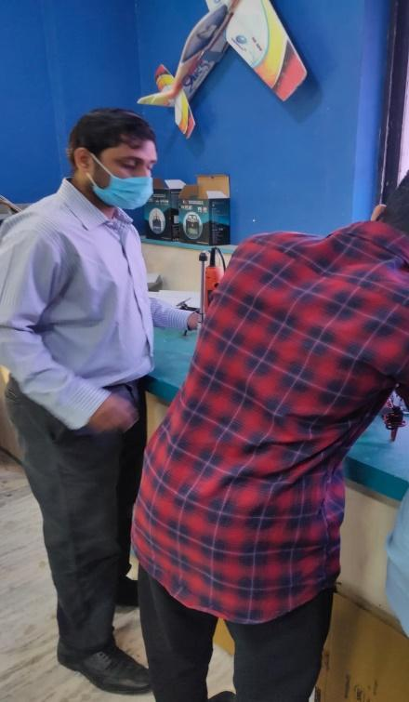**

Its our working images of our project work.

**3.4.WEIGHT CHART:**

|  |  |  |
| --- | --- | --- |
| **S.NO.** | **PRODUCT** | **WEIGHT (g)** |
| **1.** | Booms and mounts | 200 |
| **2.** | Propulsion | 760 |
| **3.** | Wings | 335 |
| **4.** | Landing gear | 194 |
| **5.** | Battery | 175 |
| **6.** | Fuselage | 100 |
| **7.** | Stabilizers | 100 |
| **8.** | Addition wiring | 85 |
| **9.** | FCS and accessories | 185 |
|  | **TOTAL** | **2,254** |

**Figure 3.4.1:** **VTOL weight estimation table**

**Figure 3.4.2:** **VTOL weight estimation chart**

**CHAPTER 4**

**4.0. COMPONENTS**

**4.1. MATERIAL SELECTION:**

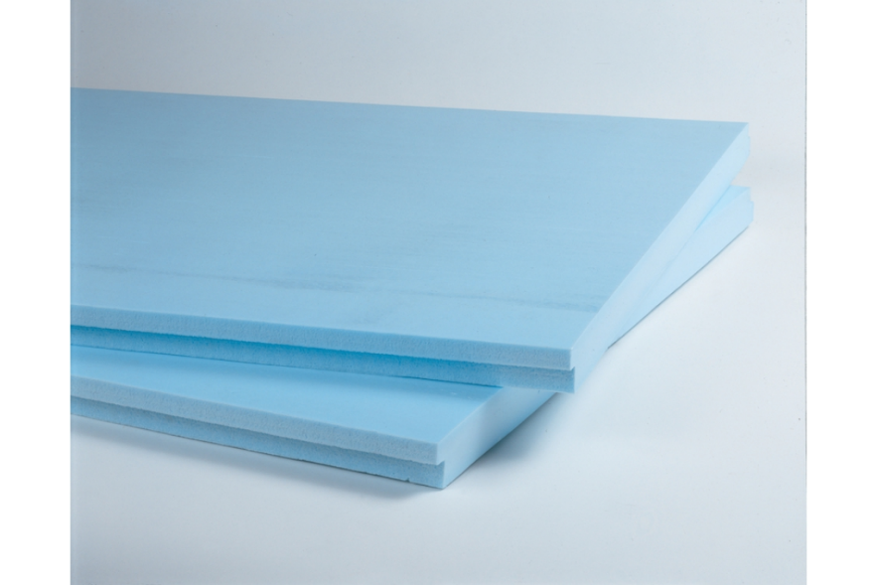

**Figure 4.1.1: XPS material**

        XPS is extruded polystyrene, or high density foam a type of foamed polystyrene board that is intended for insulation purposes. Conventionally, foamed polystyrene boards are known as EPS. XPS is undergoes a continuous extrusion process, during which the physical blowing agents are injected into the molten PS. The mixed PS, blowing agents, and other additives are subsequently cooled by the cooling extruder. As a result, the pressurized and viscous molten material are extruded through the slot die. When the material exudes from the slot die, pressure is released, and the foaming process initiates. The foamed material will pass through the calibration system to embody shapes and models.

**ADVANTAGES OF XPS MATERIAL:**

* Long term thermal resistance;
* Extra Long Durability;
* Excellent Water Resistance;
* High Compression Strength;
* Remarkable Fire Resistance;
* Outstanding Sound Absorption;
* Reputed Green Product.

**4.2. FUSELAGE:**

**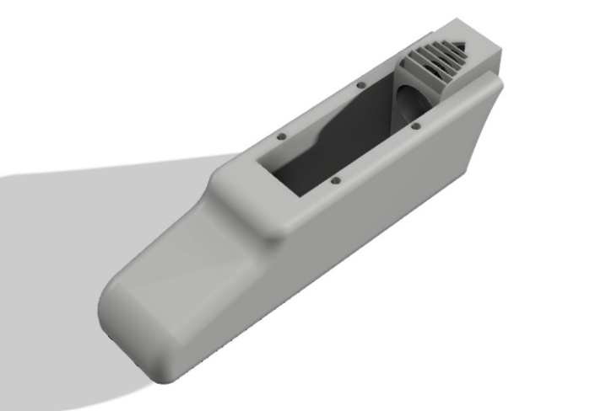**

**Figure 4.2.1: CAD Design of fuselage**

                  Fuselage breadth size has been increased for the new model to place the flight controller,battery and other connections.

**4.3. WING:**

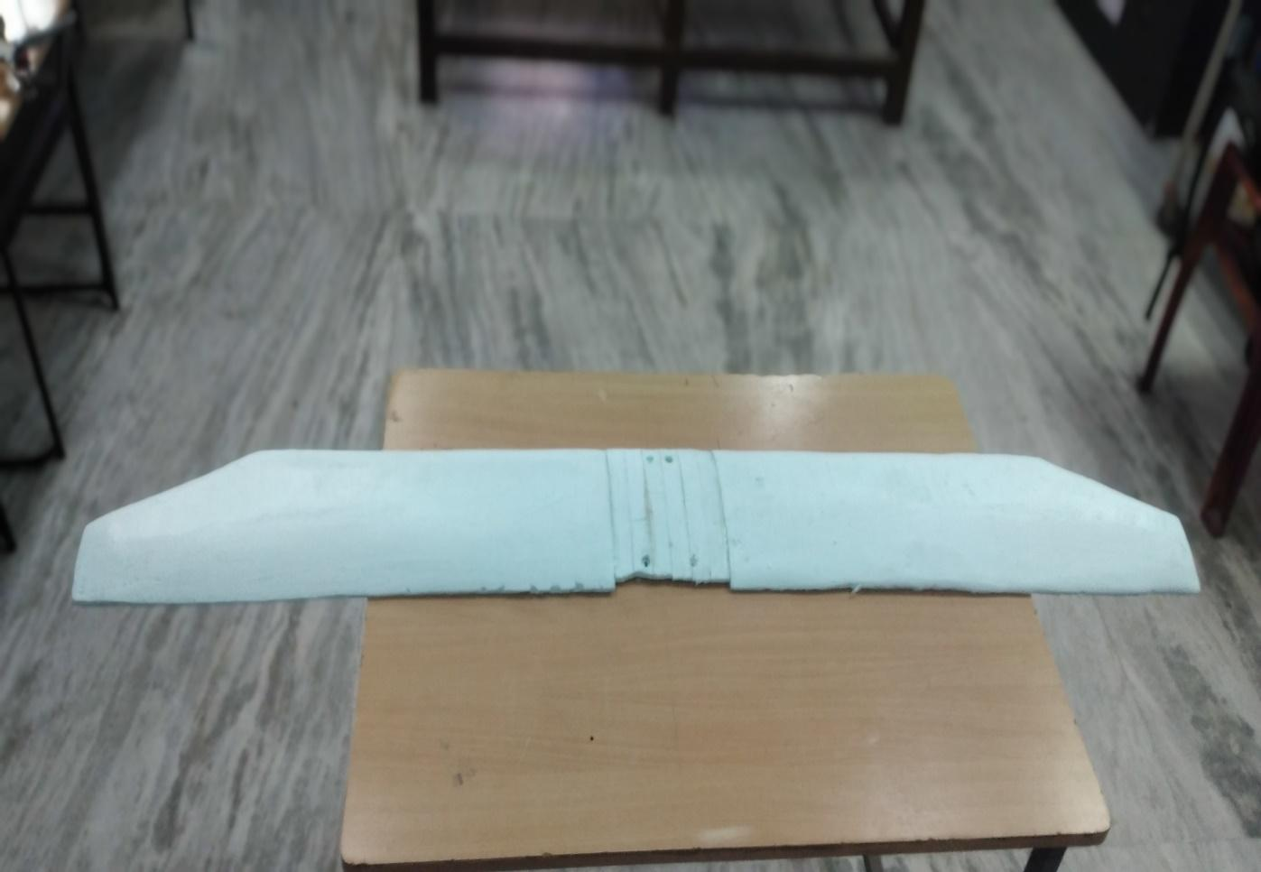

**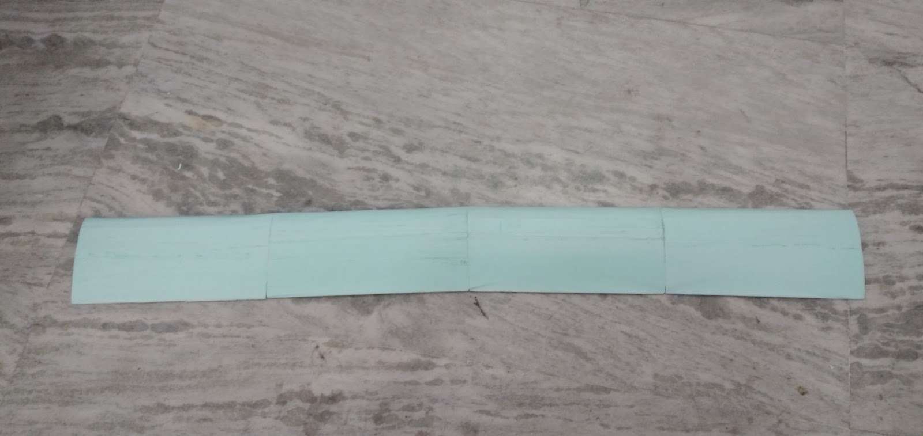**

Wing was designed with high density foam material, with some modifications. For strengthening, small composite plates were fixed to make the connections steady to fix the motors.

Therefore, we have changed the wing into a rectangular shape for steady flight.

**4.4. MOTORS:**

**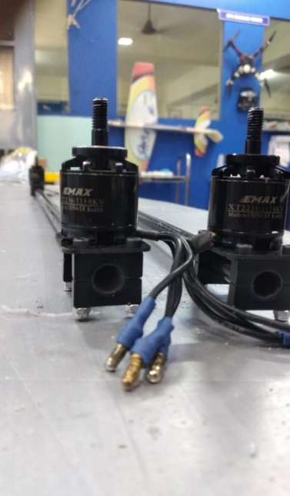**

**Figure 4.4.1: XT2216-1150KV motor**

4 motors were used for quad flying in VTOL.

Framework  :12N14P

KV               :1150KV

Length         :34.8mm

Diameter     :27.9mm

Weight         :65g

No of cells   :3S

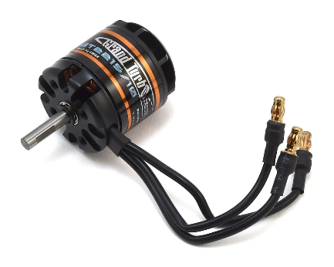

**Figure 4.4.2: 1100KV motor**

This motor is used for pusher type in VTOL which was 1100KV.It is fixed on the backside of the fuselage.

**Specifiations:**

Stator dimensions :28\*15mm

Weight :120g

Cells :3s

**4.5. BOOMS AND MOUNTS:**

**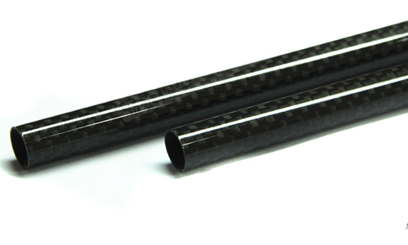**

**Figure 4.5.1: Booms**

Our Roll wrapped carbon fiber tubes are manufactured by wrapping multiple layers of 12k UD and 3k twill/plain carbon fiber prepregs around a metal mold and then cured at high temperature. The UD prepregs are used in core layers whereas the Twill/Plain is on the surface. Based on your requirement, we can also use Kevlar and glass fiber.

**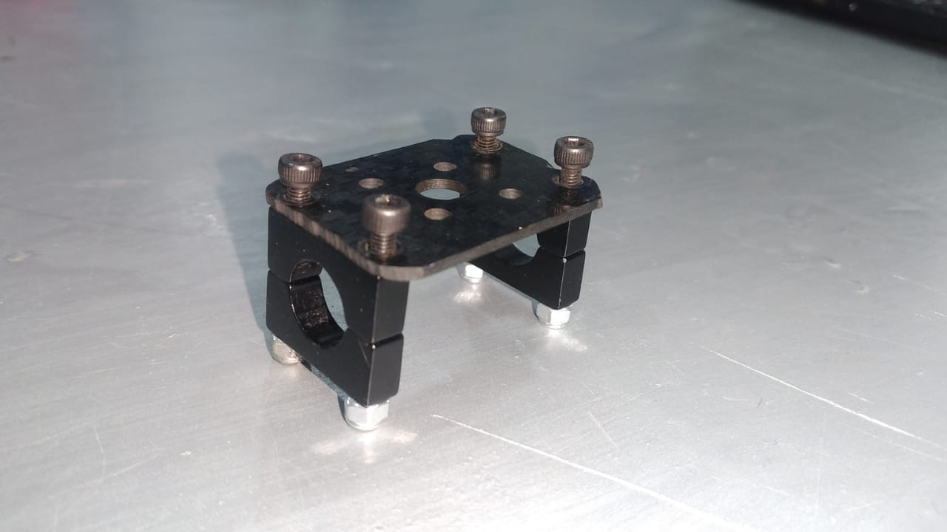**

**Figure 4.5.2: Motor mount**

This above image shows that,to mount the motor with the help of carbon fibre plate,nuts and screws were fixed on the booms.The final setup of motor on boom has shown below.

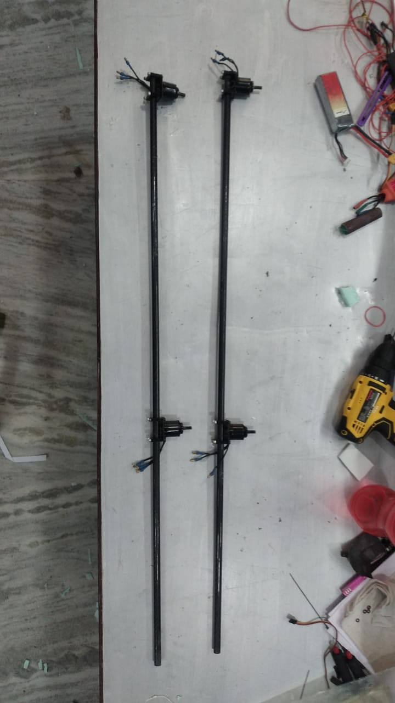

**Figure 4.5.3: Motors fixed on booms**

**4.6. BATTERY:**

**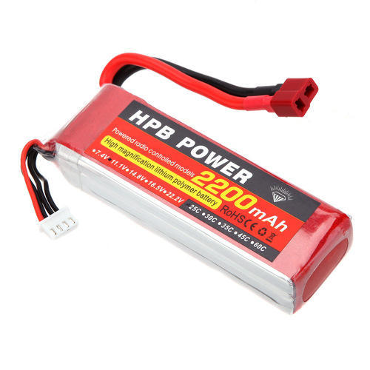**

**Figure 4.6.1: 11.1V 2200mAH LIPO Battery**

It is Capable of maximum continuous discharge rates up to 25C, placing this battery among the most powerful Li-Po battery packs in its class! It offers an excellent blend of weight, power and performance.

**Features of 11.1V 2200mAH Lipo Battery:**

* Charge Capacity( C ) : 2200mAh.
* Rated Voltage: 11.1V
* Exact weight: 150 - 160 Grams
* iLxHxW : 100\*20\*30mm Approx
* High energy density - potential for yet higher capacities.

**4.7. FLIGHT CONTROLLER:**

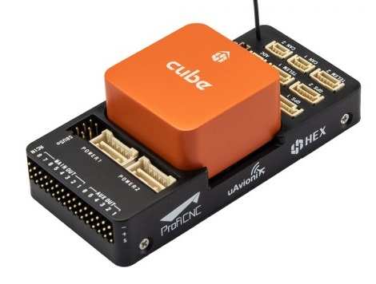

**Figure 4.7.1: Orange cube controller**

The cube orange flight controller is a flexible autopilot intended primarily for manufacturers of commercial systems.The controller is designed to be used with a domain-specific carrier board in order to reduce the wiring, improve reliability, and ease of assembly. For example, a carrier board for a commercial inspection vehicle might include connections for a companion computer, while a carrier board for a racer could includes ESCs for the frame of the vehicle.

Cube includes vibration isolation on two of the IMU's, with a third fixed IMU as a reference / backup.

## Specifications:

* Processor:
  + STM32H743ZI (32bit)
  + 400 MHz
  + 1 MB RAM
  + 2 MB Flash (fully accessible)
* Failsafe co-processor:
  + STM32F103 (32bit *ARM Cortex-M3*)
  + 24 MHz
  + 8 KB SRAM
* Sensors: (all connected via SPI)
  + Accelerometer: (3) ICM20948, ICM20649, ICM20602
  + Gyroscope: (3) ICM20948, ICM20649, ICM20602
  + Compass: (1) ICM20948
  + Barometric Pressure Sensor: (2) MS5611
* Operating Conditions:
  + Operating Temp: -10C to 55C
  + IP rating/Waterproofing: Not waterproof
  + Servo rail input voltage: 3.3V / 5V
  + USB port input:
    - Voltage: 4V - 5.7V
    - Rated current: 250 mA
  + POWER:
    - Input voltage: 4.1V - 5.7V
    - Rated input current: 2.5A
    - Rated input/output power: 14W
* Dimensions:
  + Cube: 38.25mm x 38.25mm x 22.3mm
  + Carrier: 94.5mm x 44.3mm x 17.3mm

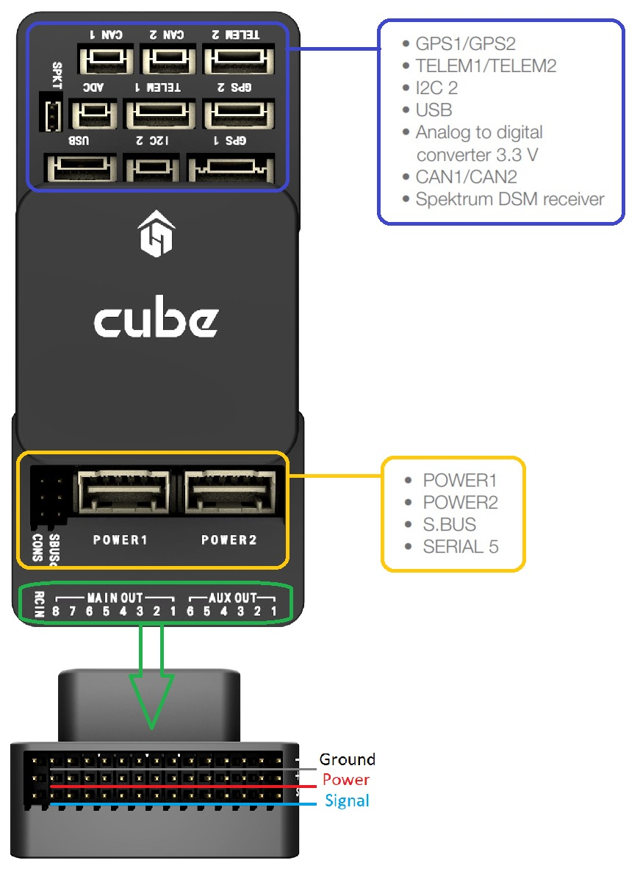 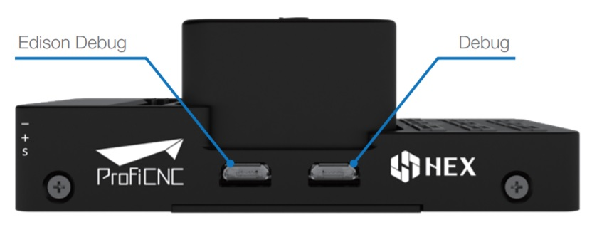**Figure 4.7.2: Top-side (GPS, TELEM etc)** **Figure 4.7.3**: **Debug ports**

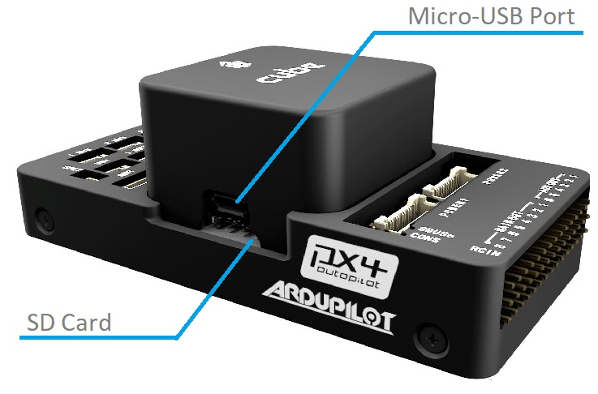

### Figure 4.7.4: USB/SD card ports

### 4.8. GPS AND RECEIVER:

**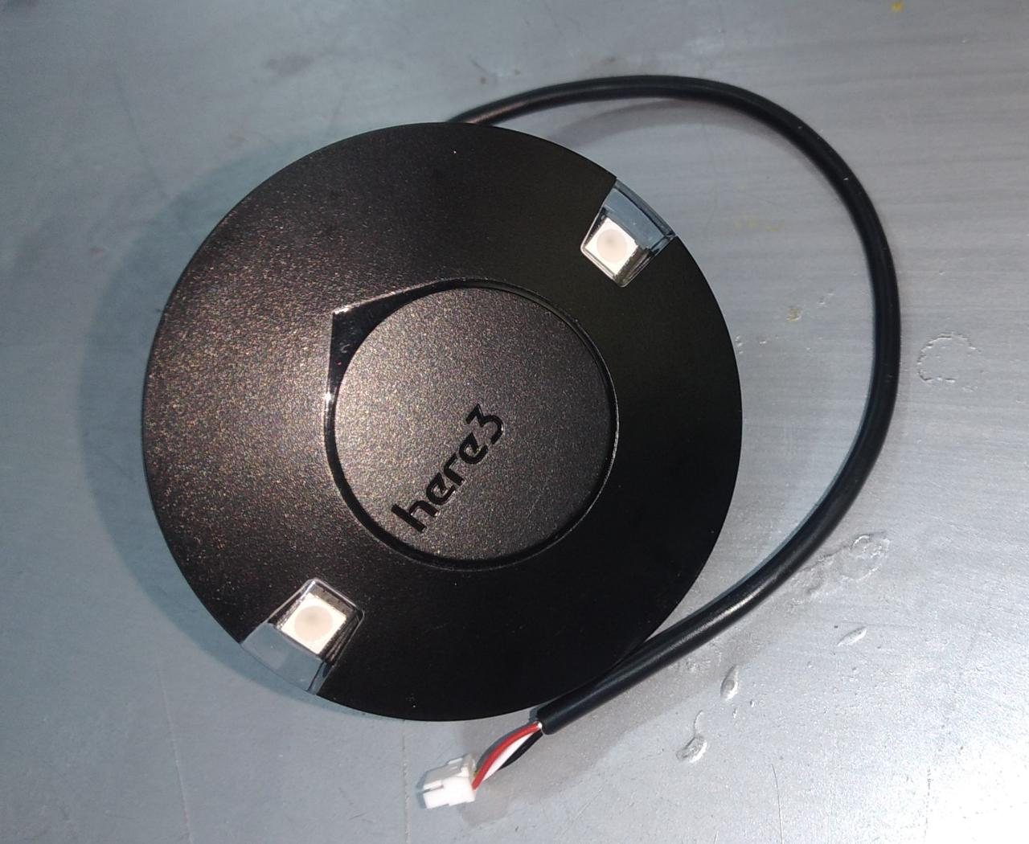**

**Figure 4.8.1: Global Positioning System**

The Here3 GPS is a high precision GNSS system that supports RTK mode, built with CAN protocol. It is also designed to be dust-proof and splash-proof up to a certain limit. Equipped with STM32F302 processor, the Here3 provides faster processing speed and better reliability.

## Features:

1. Cost-efficient high precision and RTK supported GNSS chip (base station needed for RTK). Positioning accuracy down to centimetre-level in an ideal environment.
2. Brand new design with improved visibility on signal LEDs. Better dust and water resistance (Not guaranteed to be water-proof under any situation due to the complexity of the operating environment).
3. The high data rate, upgradeability, noise immunity, and real-time features benefited from CAN protocol.
4. Equipped with STM32F302 high-performance processor in a real-time operating system. The framework developed by Hex provides additional stabilities. Supports future firmware updates.
5. Support from ground control software. Future updates will be available from Mission Planner.
6. Built-in a complete set of Inertial Measurement Unit (compass, gyroscope, and accelerometer), which satisfy advanced navigation needs.

## Specifications:

|  |  |
| --- | --- |
| **Receiver Type** | u-blox M8 high precision GNSS modules (M8P) |
| **Satellite Constellation** | GPS L1C/A, GLONASS L1OF, BeiDou B1I |
| **Positioning accuracy** | 3D FIX: 2.5 m / RTK: 0.025 m |
| **Processor** | STM32F302 |
| **IMU sensor** | ICM20948 |
| **Navigation Update Rate** | Max: 8Hz |
| **Communication Protocol** | CAN |
| **Operating Temperature** | -40℃ to 85℃ |
| **Dimension** | 68mm x 68mm x 16mm |
| **Weight** | 48.8g |

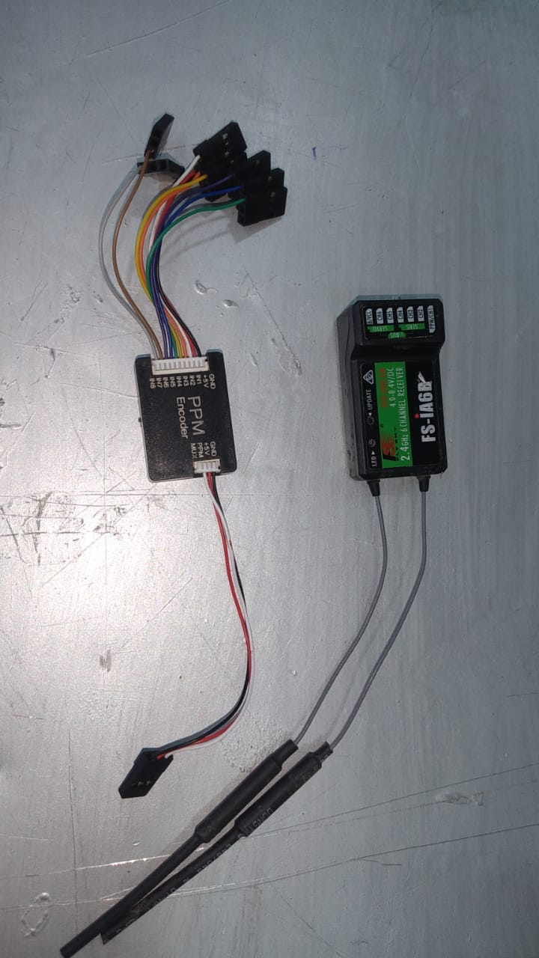

**Figure 4.8.2: Receiver (PPM)**

## FS-SRM based on ANT protocol is a new receiver with two external antennas and bidirectional transmission. It outputs PWM or PPM/ i-BUS/S.BUS signal and has a compact design. The design of the receiver is easy to install, and it adapts multicopters.

## Follow the steps below to bind in two-way binding:

1. Select [2 WAY] for RF standard of the transmitter, then put the transmitter into bind mode.
2. The receiver supports tho ways to enter bind mode: BIND button binding and BIND button binding after power-on.  
   • BIND button binding: Press and hold the BIND button of the receiver while powering on the receiver, the LED of the receiver should be flashing, indicating that the receiver is in bind mode. Then release the BIND button.  
   • BIND button binding after power-on: The receiver has not been connected to the transmitter when it is powered on. Press and hold the BIND button for 3 seconds, the LED of the receiver should be flashing, indicating that the receiver is in bind mode.  
   Then release the BIND button.
3. When the LED of the receiver is solid on, the binding process should be completed. The transmitter exits the bind mode automatically.
4. Check to make sure the transmitter and receiver functions are working correctly, repeat steps 1 to 3 (binding process) if any problems arise.

Follow the steps below to bind in one-way binding:

1. Select [1 WAY] for RF standard of the transmitter, then put the transmitter into bind mode.
2. Put the receiver into bind mode ( Refer to the description above for entering bind mode).
3. When the LED of the receiver is in slow flashing state, the binding process should be completed. You need to manually put the transmitter to exit the bind mode. Then the LED of the receiver is solid on, indicating that the binding is completed.
4. Check to make sure the transmitter and receiver functions are working correctly, repeat steps 1 to 3 (binding process) if any problems arise.

#### Firmware update:

The firmware of this receiver is updated through the FlyskyAssistant (Only version 3.0 or above is supported.This receiver can be updated via the following two ways:

1. After the binding between the transmitter and the receiver (the LED of the receiver is solid on), connect the transmitter to the computer, then open the Flysky Assistant on the computer to update the firmware.
2. Connect the transmitter to the computer. Then put the receiver to enter the forced update mode by referring to the following two ways (The LED of the receiver operates in a three-flash-one-off manner repeatedly). Afterward, open the Flysky Assistant on the computer to update the firmware.  
   • Power on the receiver while pressing and holding the BIND button for more than ten seconds, until the LED of the receiver  
   operates in a three-flash-one-off manner repeatedly, then releases the BIND button.  
   • Power on the receiver first, then press and hold the BIND button for more than ten seconds, when the LED of the  
   receiver operates in a three-flash-one-off manner repeatedly, then releases the BIND button.

**4.9. PROPELLERS:**

**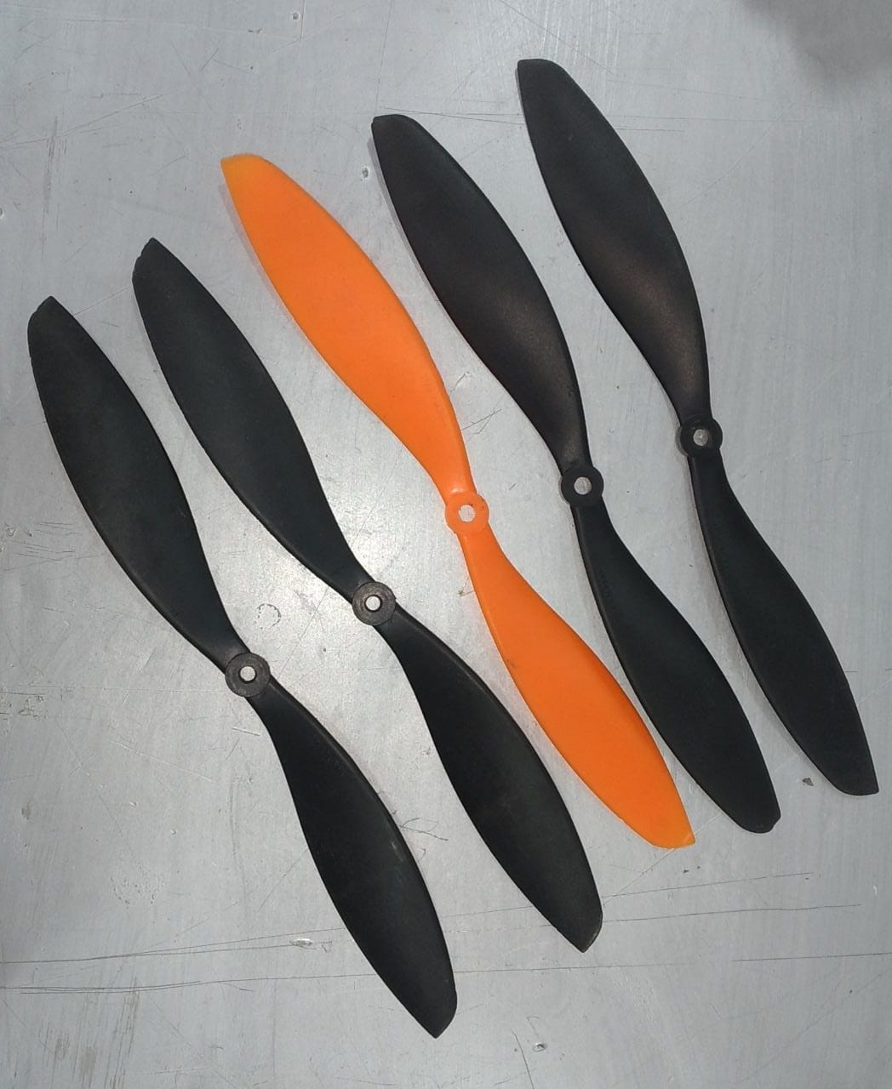**

**Figure 4.9.1: 11 inch propellers**

**4.10. TAIL CONFIGURATION:**

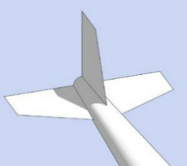 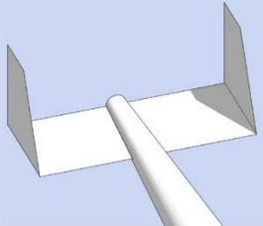

|  |  |
| --- | --- |
| **CONVENTIONAL DESIGN** | **H-TAIL DESIGN** |
| Conventional tail is a common tail design. | H-tail is a different arrangement. |
| It affects the air flow for pusher motor. | Efficiency of air flow is smooth. |
| It has one horizontal and one vertical stabilizers. | It has one horizontal and two vertical stabilizers. |

**Figure 4.10.1: Comparison of tail design**

**4.11.LANDING GEAR:**

**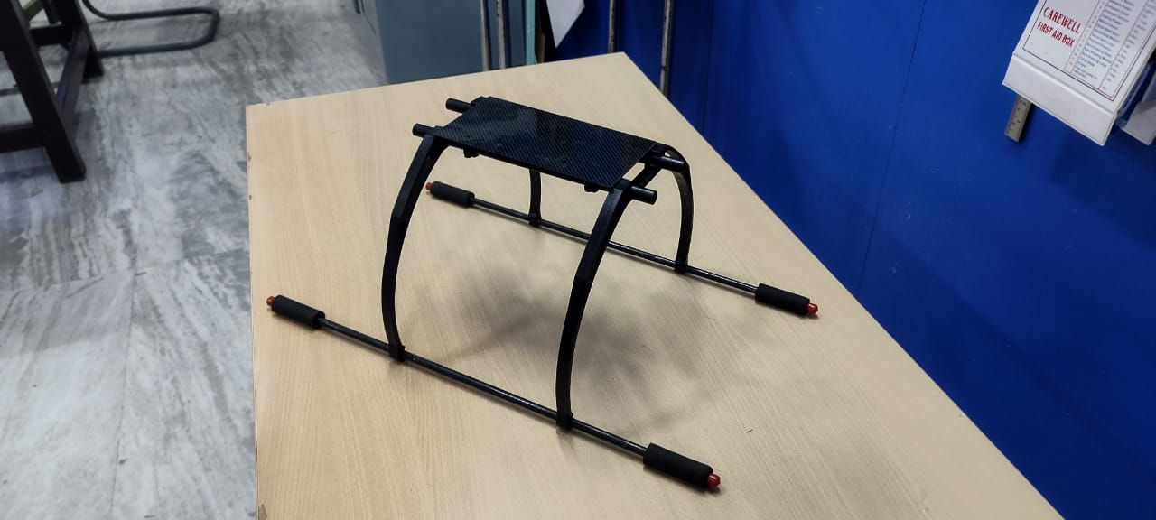**

**CHAPTER 5**

**5.0. TESTING PROCESS**

**5.1. MATERIAL WEIGHT ESTIMATION:**

| **S.NO** | **MATERIAL** | **WEIGHT** | **LENGTH** | **DIAMETER** |
| --- | --- | --- | --- | --- |
|  |  | g | cm | m |
| 1. | 0.8 mm carbon fibre | 104 | 11.5 | 0.018 |
| 2. | 1.8 mm carbon fibre | 166 | 50 | 0.008 |
| 3. | Aluminium rod | 53 | 90 | 0.011 |

**Figure 5.1.1: Material weight table**

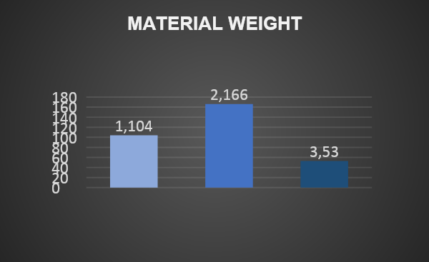

**Figure 5.1.2: Material weight chart**

**5.2. DISPLAY MODE:**

**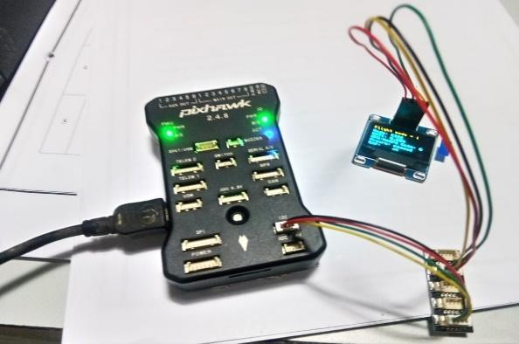 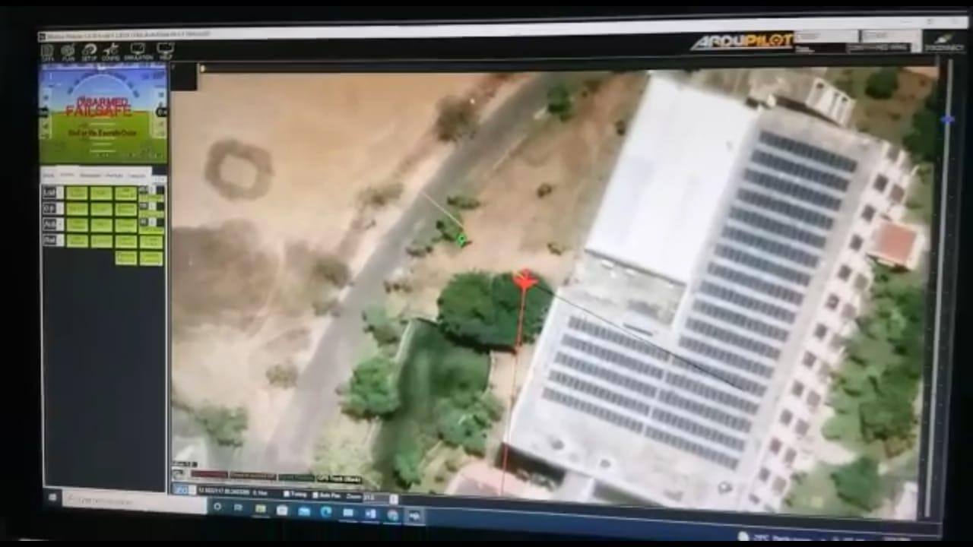**

**Figure 5.2.1: GPS mode** **Figure 5.2.2: Satellite image**

* Flight control system with all required electronics have been installed.
* Switch over mechanism has been programmed and tested.
* Inclusion of an external LCD screen for operator viewing.

For GPS, 433 MHZ radio frequency is used for telemetry data. A mission planning software runs on gps for planning, execution and control of flight. Sample work is done for moment of flight for flying over crops as purple lines to indicate show test flights carried out in our campus. Airfoil data can be analyzed through the reference paper.

**5.3. AIRFOIL SELECTION:**

**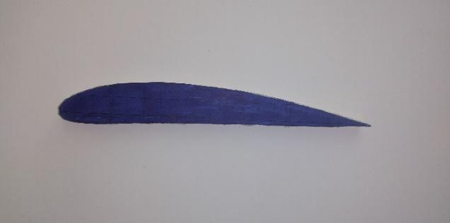** **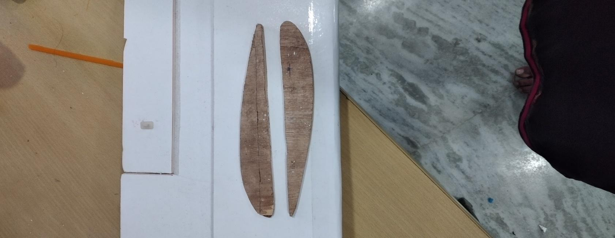**

**Figure 5.3.1: GOE526 airfoil**

According to symmetrical airfoil such as NACA 0012 has significantly lower max CL and lower stall angle. Therefore, further investigation into cambered airfoils yields the selections of CLARK Y and CLARK YM-15, as well as the GOE 526 reveals that only the GOE 526 and CLARK YM-15 have high enough max CL for the proposed design and it has a significantly higher ‘lower surface flatness’ making manufacturer easier.

Thus, the final selection is “GOE 526 airfoil”. **Chord=19 cm**

**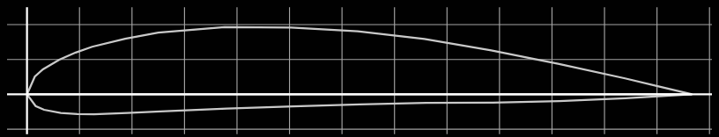**

**Figure 5.3.2: Airfoil chord image**

**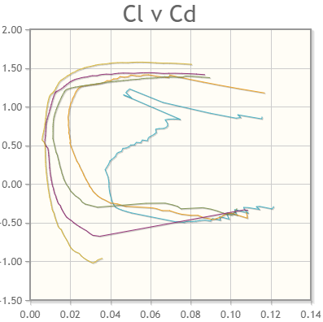** 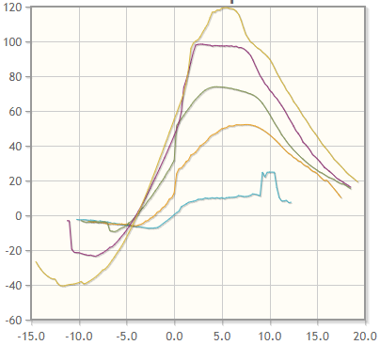

**Figure 5.3.3: Graph of Cl vs Cd Figure 5.3.4: Graph of Cl/Cd vs alpha**

**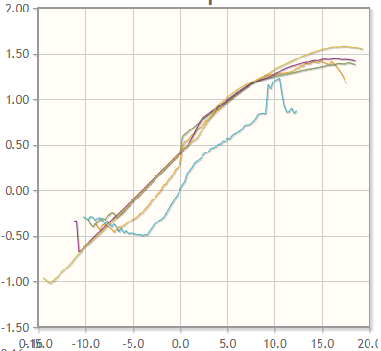 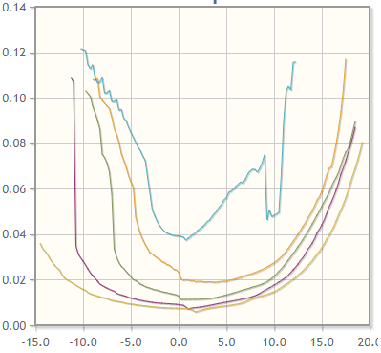**

**Figure 5.3.5: Graph of Cl vs alpha Figure 5.3.6: Graph of Cd vs alpha**

**5.4. FLAT BOTTOM AIRFOIL:**

Airfoil-GOE526

Chord length=19cm

Airfoil thick=2.4cm

Wing span=140cm

Wing area=wing span \* chord

=140\*19

=2660 sq cm

Aspect ratio=140/9

=7.3

Aileron size=1/8 (19)

=2.375

Wing loading = total weight/wing area

= 1800/2660

= 0.67 m2

**CHAPTER 6**

**6.0.** **MODES OF VTOL**



**Figure 6.0.1: Flight test**

A VTOL aircraft can fly as either a multicopter or as fixed-wing vehicle. The multicopter mode is mainly used for take off and landing while the fixed wing mode is used for efficient travel and/or mission execution.

Generally the flight modes for VTOL vehicles are the same as for [multicopter](https://docs.px4.io/v1.10/en/getting_started/flight_modes.html#mc_flight_modes) when flying in MC mode and [fixed-wing](https://docs.px4.io/v1.10/en/getting_started/flight_modes.html#fw_flight_modes) when flying in FW mode.The switch between modes is initiated either by the pilot using an RC switch or automatically by PX4 when needed in the Auto modes.

**6.1. Q-STABILIZE:**

The default parameters controlling the VTOL motors PID loops should allow most frames to initially hover uncontrollably, if the motors’ mechanics are setup and aligned correctly and esc’s calibrated.

The most important parameters controlling stability are the Roll/Pitch/Yaw PIDS. For altitude control, the vertical position controller’s parameters and Motor Thrust Scaling parameters, and for navigation/loiter the Loiter controllers’s parameters.Normally, it’s best to start by tuning the Rate Roll/Pitch P in Q-STABILIZE mode.

**6.2. STABILIZE:**

Stabilize mode puts the vehicle into straight and level flight when the RC sticks are centered, maintaining the horizontal posture against wind (but not vehicle heading and altitude).The vehicle climb/descends based on pitch input and performs a coordinated turn if the roll/pitch sticks are non-zero. Roll and pitch are angle controlled (you can't roll upside down or loop).

Stabilizedmode is much easier to fly than [Manual mode](https://docs.px4.io/v1.10/en/getting_started/flight_modes.html#manual_fw) because you can't roll or flip it, and it is easy to level the vehicle by centering the control sticks.The vehicle will glide if the throttle is lowered to 0% (motor stops). In order to perform a turn the command must beheld throughout the maneuver because if the roll is released the plane will stop turning and level itself.

**6.3.MANUAL:**

The [Manual](https://docs.px4.io/v1.10/en/flight_modes/manual_stabilized_mc.html) mode stabilizes the multicopter when the RC control sticks are centered. To manually move/fly the vehicle you move the sticks outside of the center.This multicopter mode is enabled if you set either Manual Modes for an MC vehicle.When under manual control the roll and pitch sticks control the angle of the vehicle (attitude), the yaw stick controls the rate of rotation above the horizontal plane, and the throttle controls altitude/speed. As soon as you release the control sticks they will return to the center dead zone. The multi-copter will level out and stop once the roll and pitch sticks are centered. The vehicle will then hover in place/maintain altitude - provided it is properly balanced, throttle is set appropriately, and no external forces are applied (eg. wind). The craft will drift in the direction of any wind and you have to control the throttle to hold altitude.

**CHAPTER 7**

**7.0.WORK ANALYSIS**

**7.1. FLOW CHART:**

Start

Flight mode

Vtol mode

Searching for landing

Landing process

End

**7.2. WORKING PROCEDURE:**

**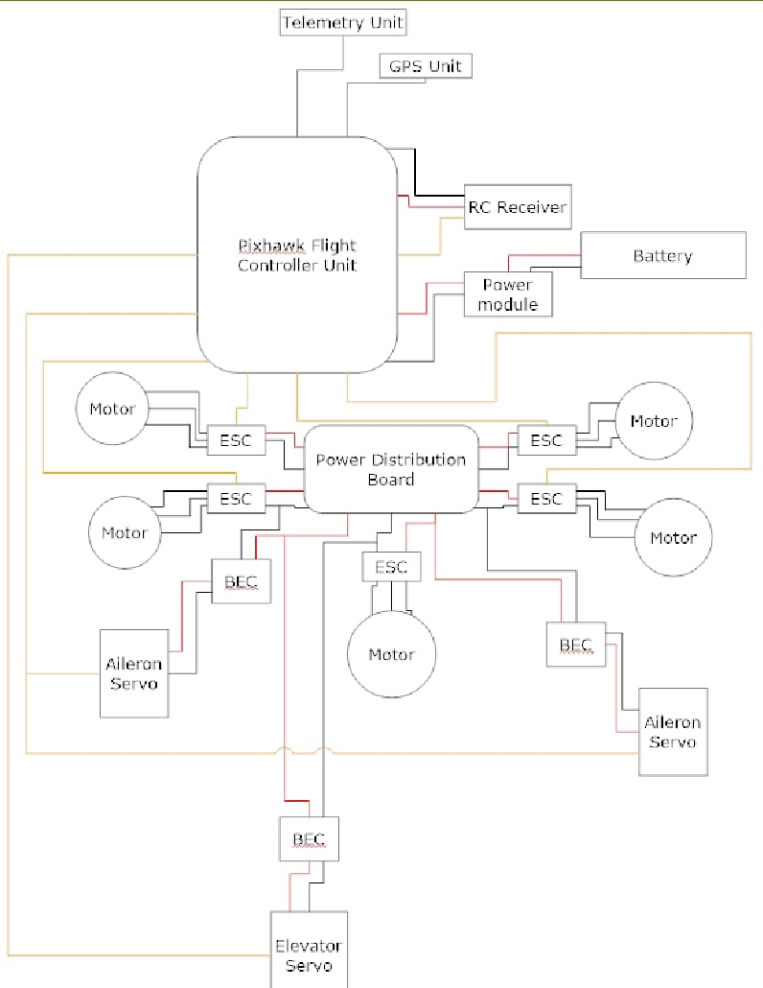**

**Figure 7.2.1: Connection diagram**

The two configurations are propelled by electric and flying maneuvers are done using a flight control system and controlled remotely with a radio frequency transmitter and receiver. Switching of modes are executed manually from the switch assigned on the radio transmitter and controls are programmed to the flight controller for actuating the controls based on the flying mode.For flying the model, programming is done on flight controller. The four motors on left and right side of the wing is used for lifting and landing the flight. Then, pusher motor which is fixed back side of the fuselage were used to forward thrust.

|  |  |
| --- | --- |
| **ELEMENTS** | **QUANTITY** |
| MOTOR | 5 |
| ESC | 5 |
| BATTERY | 1 |
| GPS | 1 |
| RECIEVER AND PPM | 1 |
| SERVOS | 3 |

**7.3.EQUIPMENTS:**

**Figure 7.3.1: Table of elements**

**CHAPTER 8**

**8. RESULT & CONCLUSION**

This results the VTOL process has been designed with different modes to crop monitoring. The developed prototype of pusher type fixed wing VTOL (Vertical Take Off and Landing) has been done and demonstrated the feature of switching between VTOL mode and fixed wing mode. Weight estimation chart has been prepared for our product. Lighter the aircraft, we obtain better manouverability.

Multi spectral camera has been included for the purpose of crop yield estimation. In addition, we are included a concept of optical flow altitude management system which will enable very low altitude flight operations. Very low altitude flight operations will result in enhanced estimation of crop yield.VTOL was very stable,quick take-off and forward thrust has been achieved.

**CHAPTER 9**

**9.FUTURE WORKS**

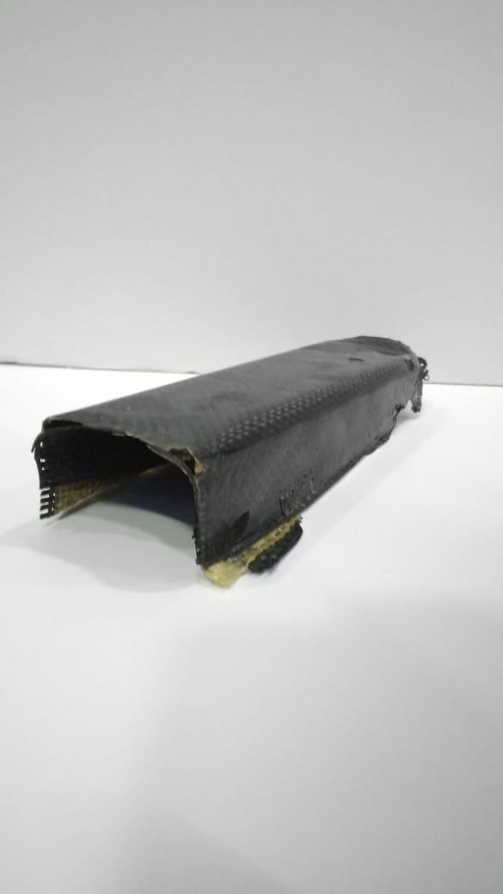 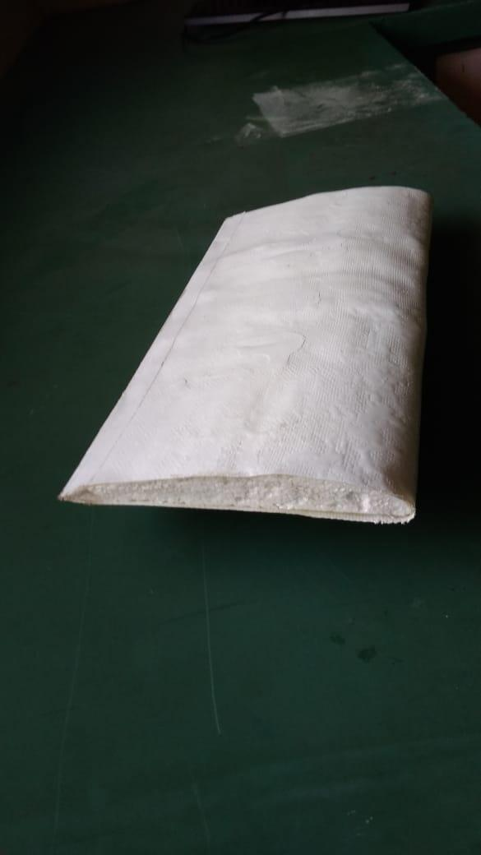

**Figure 9.0.1: Hybrid Figure 9.0.2: Glass fibre**

A composite material is a material which is produced from two or more constituent materials.It is a process of fabric ,resin and hardener.For curing process epoxy or bibimalide has been used.GSM(gram/sq m) and CPT(curved ply thickness) are used for different calculations.

It has different types of manufacturing process:

1.Wet lay up [open moulding, closed moulding, vacuum moulding]

2.Compression moulding

3.Resin infusion

Therefore,the first image was hybrid which was done in closed moulding process.The second image was glass fibre which was done in open moulding.These were tested with airfoil structure of GOE 526 for light weight wing which can be used in future work.

And also we can use this VTOL for agriculture irrigation purpose in future.

**CHAPTER 10**

**10.REFERENCES**

1. Janith kalpa Gunarathna; Rohan Munasinghe. (Development of a quad-rotor **fixed**-**wing hybrid**unmanned aerial vehicle).
2. Seunghee Yu, Yongjin kwon. (Development of VTOL drone for stable transit flight).
3. Torbjorn Kringeland. (Modelling and control of a vertical take-off and landing fixed-wing unmanned arial vehicle.)
4. Puspita Triana Dewi , Harish Mahatma Putra , Ghozali Suhariyanto Hadi , Tata Sudiyanto , Aris Budiyarto , and Agus Budiyono. (Flight test data analysis of hybrid vertical take-off and landing unmanned aerial vehicle);.
5. [David Orbea](https://ieeexplore.ieee.org/author/37086281100), [Jessica Moposita](https://ieeexplore.ieee.org/author/37086281728), [Wilbert G. Aguilar](https://ieeexplore.ieee.org/author/37086056733), [Manolo Paredes](https://ieeexplore.ieee.org/author/37088566854), [Rolando P. Reyes](https://ieeexplore.ieee.org/author/37086275290), [Luis](https://ieeexplore.ieee.org/author/37086275914) [Montoya](https://ieeexplore.ieee.org/author/37086275914). (Vertical take-off and landing with fixed rotor);2017.
6. Simultaneous Execution of Quad and Plane Flight Modes For Efficient Take-Off of Quad-Plane Unmanned Aerial Vehicles. (A. A. J. K. Gunarathna 1 and S. R. Munasinghe);2021.
7. Sai Kumar A, Avinash B, Vamsi Krishna C. (Conceptual Design of Hybrid UAV);2015.
8. [Ugur Ozdemir](https://link.springer.com/article/10.1007/s10846-013-9900-0#auth-Ugur-Ozdemir), [Yucel Orkut Aktas](https://link.springer.com/article/10.1007/s10846-013-9900-0" \l "auth-Yucel_Orkut-Aktas), [Aslihan Vuruskan](https://link.springer.com/article/10.1007/s10846-013-9900-0" \l "auth-Aslihan-Vuruskan), [Yasin Dereli](https://link.springer.com/article/10.1007/s10846-013-9900-0#auth-Yasin-Dereli), [Ahmed Farabi Tarhan](https://link.springer.com/article/10.1007/s10846-013-9900-0#auth-Ahmed_Farabi-Tarhan), [Karaca Demirbag](https://link.springer.com/article/10.1007/s10846-013-9900-0#auth-Karaca-Demirbag), [Ahmet Erdem](https://link.springer.com/article/10.1007/s10846-013-9900-0#auth-Ahmet-Erdem), [Ganime Duygu Kalaycioglu](https://link.springer.com/article/10.1007/s10846-013-9900-0" \l "auth-Ganime_Duygu-Kalaycioglu), [Ibrahim Ozkol](https://link.springer.com/article/10.1007/s10846-013-9900-0#auth-Ibrahim-Ozkol) & [Gokhan Inalhan](https://link.springer.com/article/10.1007/s10846-013-9900-0" \l "auth-Gokhan-Inalhan). (Design of a Commercial Hybrid VTOL UAV System); 2014.

# [Guillaume Ducard](https://ieeexplore.ieee.org/author/37294603500), [Minh-Duc Hua](https://ieeexplore.ieee.org/author/37568793500). (Modeling of an unmanned hybrid aerial vehicle); 2014.

1. Ghozali Suhariyanto Hadi, Muhammad Ramadhan Kusnaedi, Puspita Dewi, Aris Budiyarto and Agus Budiyono. (Design of Avionics System and Control Scenario of Small Hybrid Vertical Take-Off and Landing (VTOL) UAV);2014.